Release Note

Purchase Invoice Description

# 1 Basic Details

|  |  |
| --- | --- |
| Customer |  |
| Customer Name | N/A |
| Customer PM  (Where appropriate) | N/A |

|  |  |
| --- | --- |
| Release Control |  |
| Reference No. |  |
| Author | Marcus Ambra |
| Release | 1905-01R |
| Risk Level | High |
| Release Date | 05/06/2019 |
| Release Media | FOB |
| Release Reason | Incident |
| Database Version | Dynamics NAV 2016 |
| Package Name | NA |
| Delivery Method | NA |
| Customer Approval  (Delivery) | NA |

|  |  |
| --- | --- |
| Work Detail |  |
| Project Name | Support |
| Project Manager | NA |
| Project Phase | Support |
| Person (Developer/Consultant) | Marcus Ambra |
| Functional Area | Purchase Invoice |
| Reviewer/Approver (Peer/Senior) |  |
| Design Reference | NA |
| Development Release note no. | NA |

# 2 Overview

Customer logged a request with Purchase Invoices “description” which they want to keep the same description from the Purchase Line once posted in the GL.

Currently the standard NAV creates GL entries “description” as per below:

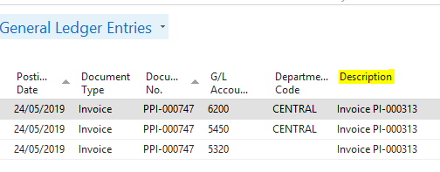

The customer wants to keep the same description from the purchase line as per the example below.

The Bal. Account will hold the standard description.

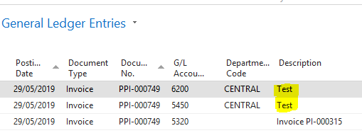

## Risk Level

This release has a High risk level for the following reasons:

.

We have added a new field and added a code in the table 49 and we have added a code in the codeunit 90 which is responsible for postings in NAV.

## Business Requirements

### Issues Addressed

#### 2.2.1.1 Issues Resolved from Previous Build

The following issues have been marked as development completed and are ready for testing.

|  |  |  |
| --- | --- | --- |
| Issue | Summary | Reported by |
| NA | NA |  |

#### Known Outstanding Issues

|  |  |  |
| --- | --- | --- |
| Issue | Summary | Reported by |
|  | NA |  |

## Assumptions

Please note if the lines have the same GL Account and the same description then the lines will be compressed in one and the first line description will be displayed in the General Ledger Entries.

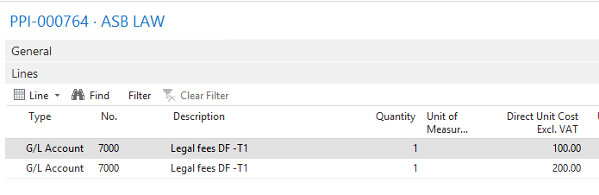

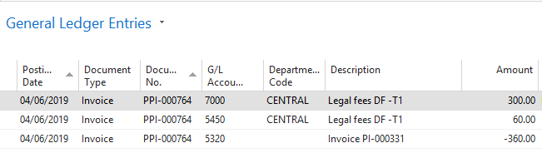

# 3 Technical Details

## 3.1 Summary of Solution Modifications

**Table: 49 – Invoice Post. Buffer**

We have added a new field called “Posting Description”

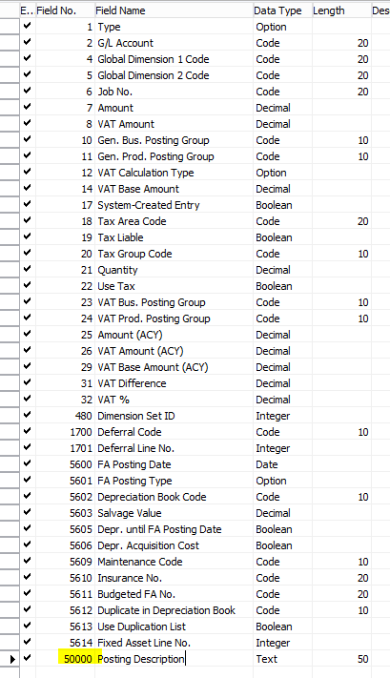

**Table: 49 – Invoice Post. Buffer**

**Keys: Posting Description**

The new key is needed to allow more then 2 lines with the same GL Account.

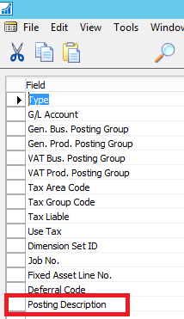

**Table: 49 - Invoice Post. Buffer**

**Trigger: PreparePurchase**

We have added the folowing code:



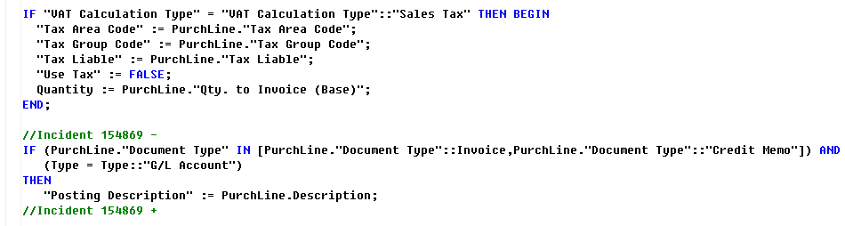

**Codeunit: 90 – Purch.-Post**

**Function: SetupGenJnlLine**

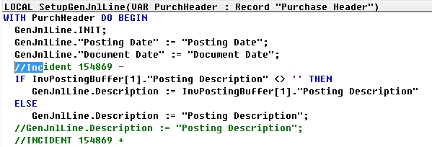

### 3.1.1 Modifications

The following new modifications have been completed and tested:

|  |  |  |  |
| --- | --- | --- | --- |
| Reference | Source | Type | Summary |
|  |  |  |  |

## 3.2 Object Changes

**Important Note**: If there is any discrepancy between the Original Object details and the corresponding Object Details in your database, please do not import them, but inform K3 immediately with details.

### 3.2.1 Object Verification

|  |  |
| --- | --- |
| Source database object changes were developed in |  |
| Date development objects compared to live | 04/06/2019 |

### 3.2.2 Existing

|  |  |  |  |  |  |  |
| --- | --- | --- | --- | --- | --- | --- |
| Object Type (table, form, etc.) | Object ID | Name | Modified | Version | Date | Time |
|  |  |  |  |  |  |  |



### 3.2.3 New

|  |  |  |  |  |  |  |
| --- | --- | --- | --- | --- | --- | --- |
| Object Type (table, form, etc.) | Object ID | Name | Modified | Version | Date | Time |
|  |  |  |  |  |  |  |



# 4 Summary of Data Fix

## 4.1 Preparation for Data

## 4.2 Steps to Perform Data Fix

## 4.3 File Changes

|  |  |  |
| --- | --- | --- |
| File name | New Version (where applicable) | File Usage (for information only, as a summary) |
|  |  |  |
|  |  |  |

|  |  |
| --- | --- |
| File name | File Type |
|  |  |
|  |  |

# 5 Deployment Steps

## 5.1 Pre-Requisites

**Important Note:**  If there is any discrepancy between the Original Object details and the corresponding Object Details in your database, please do not import them, but inform K3 immediately with details.

### 5.1.1 Any Additional License Requirements

### 5.1.2 Dependencies

## 5.2 Distributed Files

NA

## 5.3 Backup Details / Rollback

Restore previous version of objects from back up file provided

## 5.4 Installation / File System Updates

NA

## 5.5 Restarts Required

Information on any services or application restarts required:

|  |  |  |  |
| --- | --- | --- | --- |
| Action | Service Name | Responsible | Remarks |
| Till Restart Required | Not required |  |  |
| DD Restart Required | Not required |  |  |
| NAS Restart Required |  |  |  |
| Web Service Restart Required |  |  |  |

## 5.6 Data Set Up

## 5.7 Scheduler Set Up

### 5.7.1 Job Type (Batch of Replication Job)

### 5.7.2 Code Unit to be Run by Batch Job

### 5.7.3 Time Intervals and Frequency

## 5.8 Post Deployment Testing Steps

Please ensure your testing is proportionate to the level of risk.

### 5.8.1 To Test Code

Once imported the new objects:

1. Create a new purchase invoice.
2. Add a new line, type = GL account
3. Add an additional line with type as GL Account
4. Post the Invoice
5. Open the GL entries and confirm if the description matches with the description from the purchase invoice line.

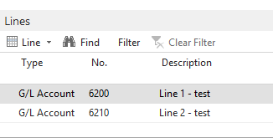

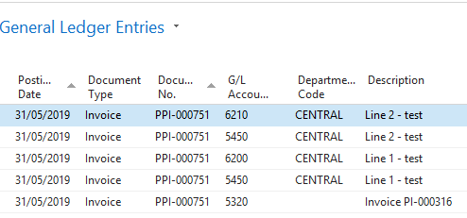

### 5.8.2 To Test Data Fix

Not required

# 6 Quality Assurance

## 6.1 Testing Completed

NA

## 6.2 Code Review / Testing

|  |  |  |
| --- | --- | --- |
|  | Name | Date completed |
| Unit Test completed by |  |  |
| Code Review completed by |  |  |
| Testing completed by | Marcus Ambra | 04/06/2019 |
| UAT testing completed successfully | Marcus Ambra | 04/06/2019 |

# 7 Additional Information

## 7.1 3rd Party Products Released

|  |  |  |
| --- | --- | --- |
| Product | Build | Remarks |
|  |  |  |
|  |  |  |
|  |  |  |

## 7.2 Points to Note

None

# 8 Sign Off

|  |  |  |  |
| --- | --- | --- | --- |
| Action | Name | Signature | Remarks |
| Released By | Marcus Ambra | Marcus Ambra |  |
| Approved By |  |  |  |

All objects/changes moved in to your live environment by yourself or otherwise, are considered complete and approved. Any further changes required after this stage may be considered a new change request.

Please be aware that objects/changes not moved into your live environment within a reasonable amount of time, upon completed user acceptance testing, may cause conflict with other objects/changes.